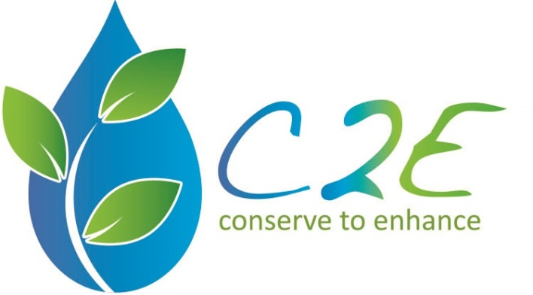
Application Instructions

This is a fillable Word document, which allows you to type in the gray text boxes and select check boxes throughout. Please read the Tucson C2E Grant Information Sheet before beginning your application. Save the completed application with your proposed project title as the file name.

This year the Tucson C2E application process has changed to a two-step procedure. The intent is to make the application process easier for you. You will first submit this Step 1 application. Then if your project is selected to proceed for further evaluation, you will be provided with a Step 2 application.

Requirements for 2017 Projects

All C2E-funded projects must meet the following criteria. Submissions that do not meet these criteria will be automatically disqualified.
- FUNDING GOAL: Due to the availability of City of Tucson Rainwater Harvesting rebates for curb cuts and basins, we are focusing on funding projects that are physically adjacent to washes OR create significant habitat and green space.
- The proposed project must be located within Tucson Water’s service area. If the water bill is from Tucson Water, your neighborhood or organization qualifies to submit.
- The project site must have a demonstrable connection to a designated urban wash or riparian area.
- The requested C2E funds, as outlined in the project budget, may not exceed $9,600.
- A 50% match from the applicant is required (this may include donated materials, equipment, and services; see Info Packet for details). An estimated total budget is requested for the Step 1 application; a final budget is not required until Step 2.
- All landowners, public and private, who are directly affected by the proposed project must submit a letter of support, and copies of these letters must be included in the Step 1 application packet (see Letter of Support template).

Deadline: Step 1 Applications are due by 05/31/17 at 5:00 PM.

Submit your completed application packet via email to Tucson@conserve2enhance.org

The Tucson C2E Advisory Council and its Grants Subcommittee will evaluate the applications in early June. Finalists will move on to application Step 2. The C2E Advisory Council will make its selection in July, and funded projects can begin in August 2017.

Although it is not mandatory, we strongly recommend attending a free Grant Workshop. The 2017 workshop will be held on Tuesday, 5/2/17 from 5:30 – 7:00 PM in the Ward 6 Community Room (3202 E 1st Street). We will explain the goals of the C2E program, cover the C2E grant process, and offer application guidance. Please come with questions! RSVP to Tucson@conserve2enhance.org
Please RSVP to tucson.c2e@gmail.com by ______.

Project Title:

Project Location:

Key Project Roles:

Project Manager Information

Name:

Address: City: State: Zip:

Phone: Email:

Each project must have a Project Manager who will serve as the liaison with C2E. Discuss this person’s experience managing projects.

Technical Expert Information

Name:

Address: City: State: Zip:

Phone: Email:

Certifications, Registrations and Expertise Areas:

Each project must have a Technical Expert with some relevant experience to lead the project design. Please attach resume or bio of the Technical Expert.

Fiscal Agent Information

Name:

Address: City: State: Zip:

Phone: Email:

Each project must have a fiscal agent that will accept and manage funds, including payment of any subcontractors and reimbursement requests. This must be a member of you team, such as a treasurer of your neighborhood association. Discuss this person’s experience managing finances for a group.

Project Questions

- In broad terms discuss your project, noting what problems you are trying to address and what benefits your project will create.

- Please attach a project site map with aerial view. Label key features like streets, washes and proposed project features.

- In the space below describe the location of the project site. Is there any functional connection to washes, waterways, and riparian areas? Who is the property owner? Are you aware of any permits that would be needed? If so, please discuss your plan to address permits.

- How do you plan on establishing vegetation on your project site? Discuss your methodology and sources. Discuss any anticipated water savings that will be made possible by the project. (Examples include utilizing a source of water that is currently not used, removing existing irrigation, etc.)

- How will the finished project be maintained after C2E funding has ended? Please discuss your plans for long-term maintenance of the site. Please address litter clean-up, weeding, trimming vegetation, watering new plants, maintaining and repairing earthworks and infrastructure after storms, and long-term control of invasive species (e.g., buffelgrass, Bermuda grass, undesirable volunteer trees).

- What makes this project unique? How does this project relate to this year’s funding goal on page 1?

- What is your estimated project budget?

